Git PUSH <https://www.youtube.com/watch?v=QJ0iUNe27c8>

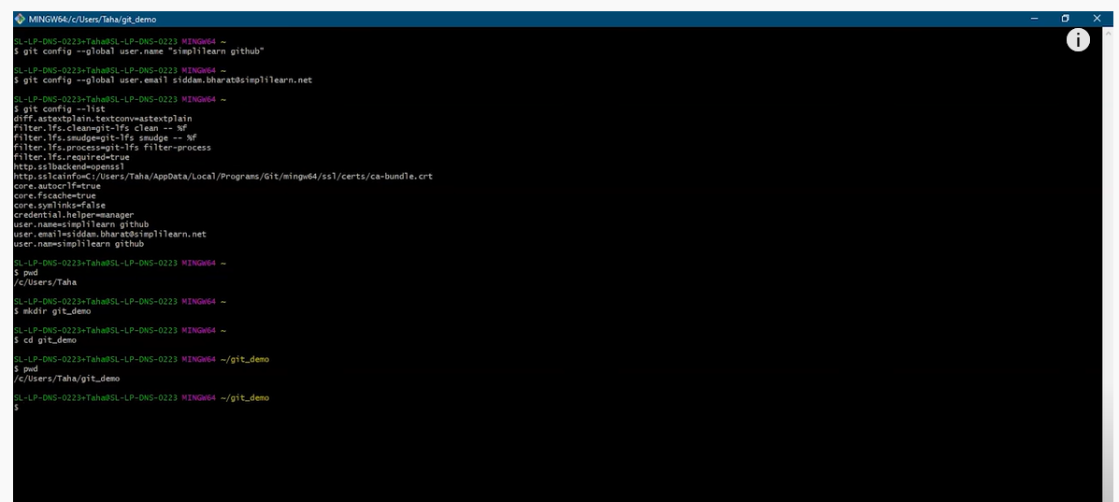

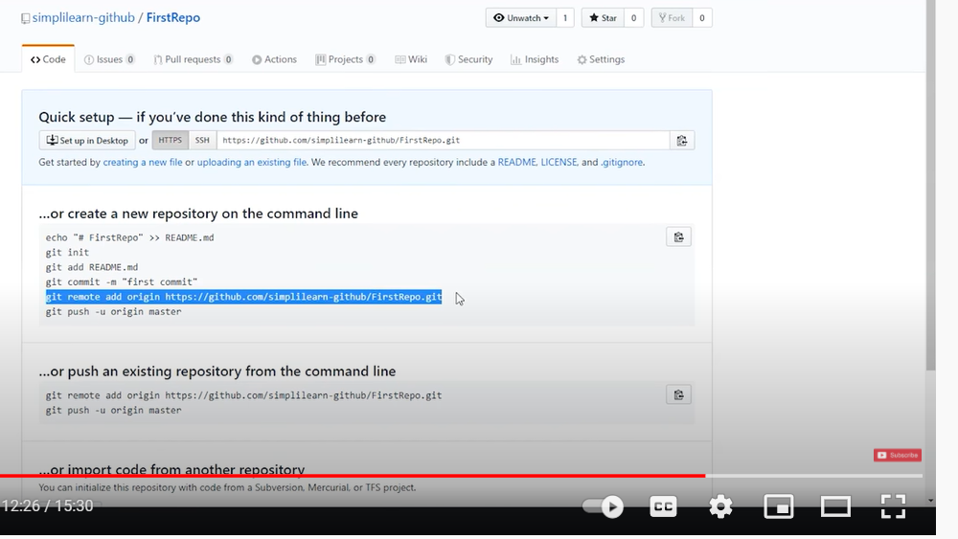

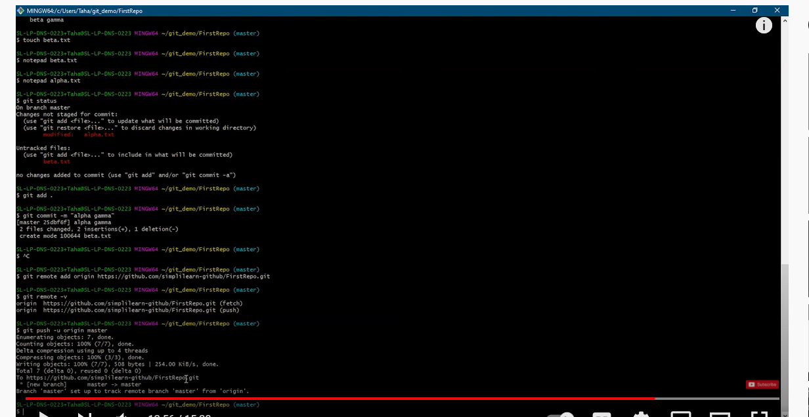

ls -lt

ls -la

How to exit bash script CTRL+Z

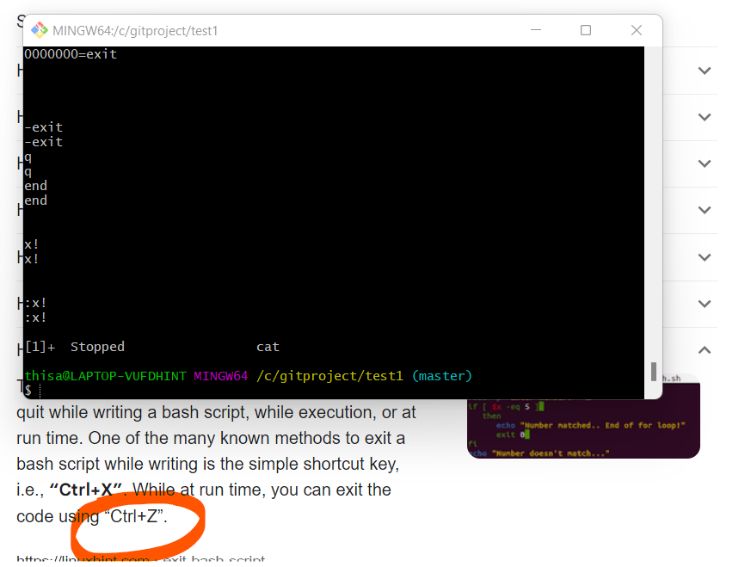

=====================================================================================

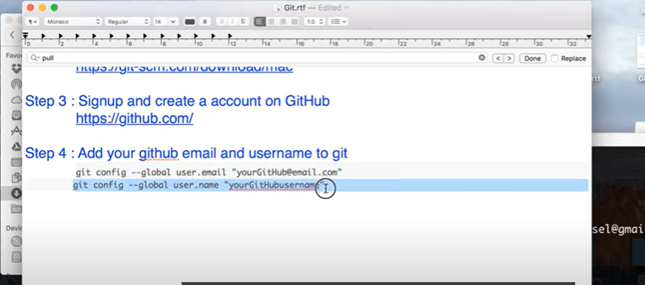

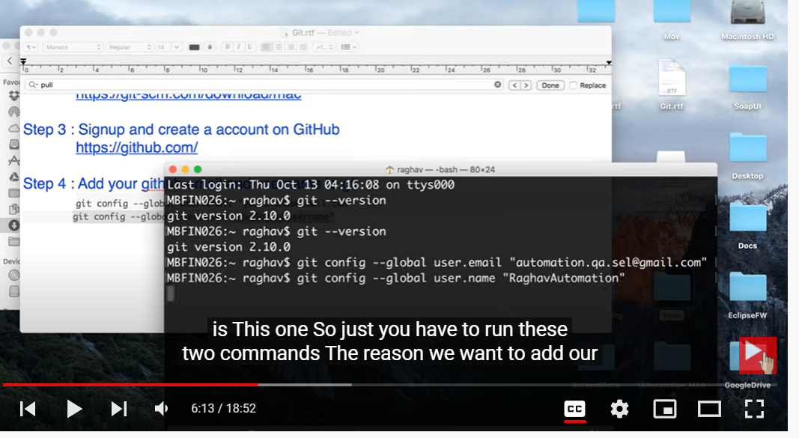

To rename the file from example4 to example3 ($ git mv example4.txt example3.txt)

$ git status

On branch master

Changes to be committed:

(use "git restore --staged <file>..." to unstage)

renamed: example4.txt -> example3.txt

INITIALIZE directory in the PROJECT folder

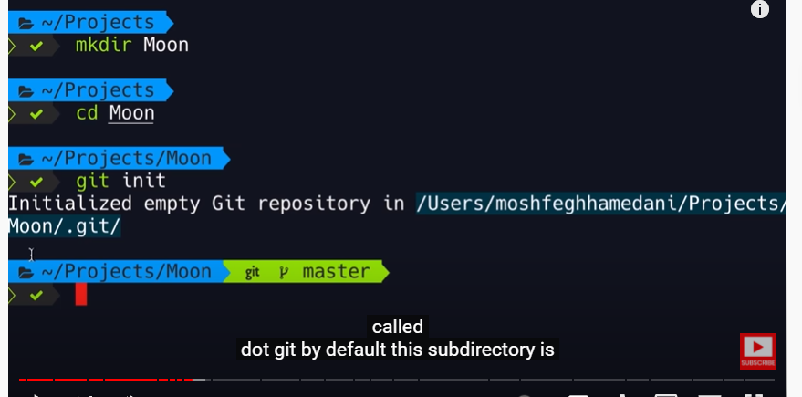

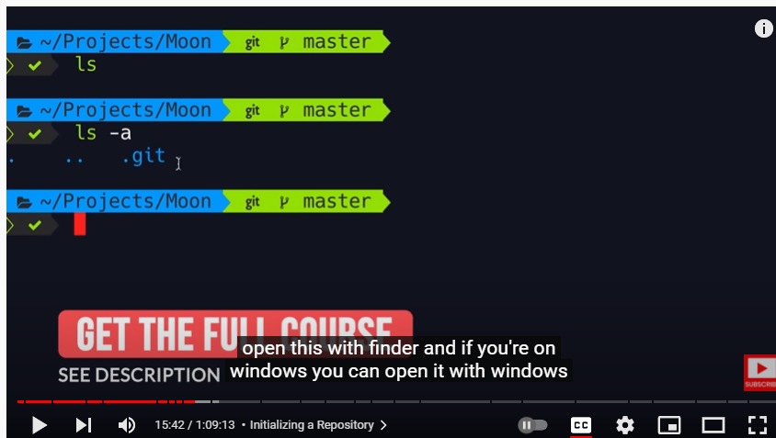

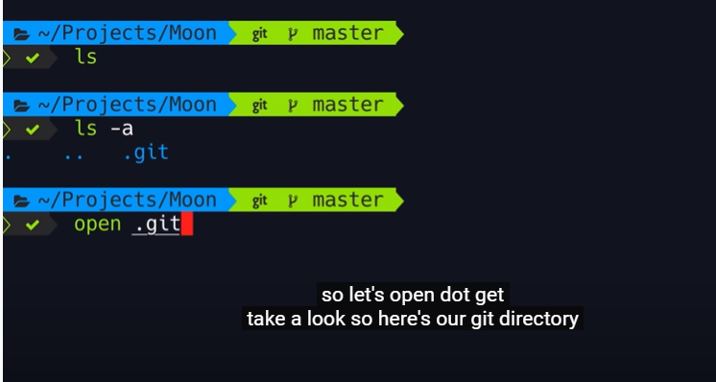

APPEND FILE

>> to append in the file

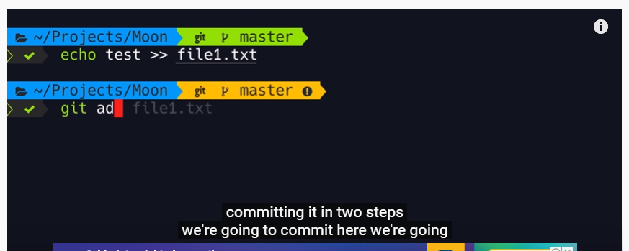

so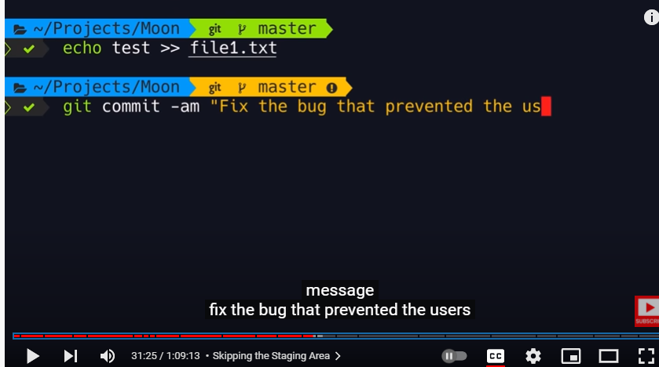

All modified files and give some description by single command

GITPROJECT folder already created in local drive inside of that I am cloning this central repositry file(testrepo)

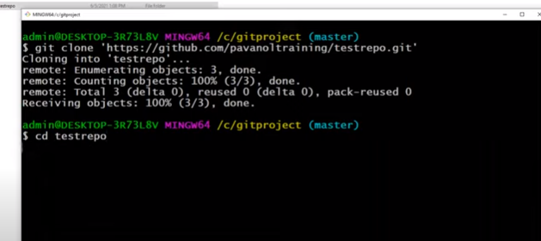

Cat command used to list out the content inside of txt file

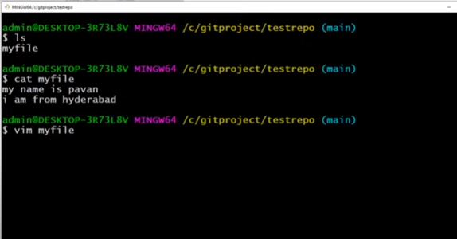

Modifying file in the testrepo folder

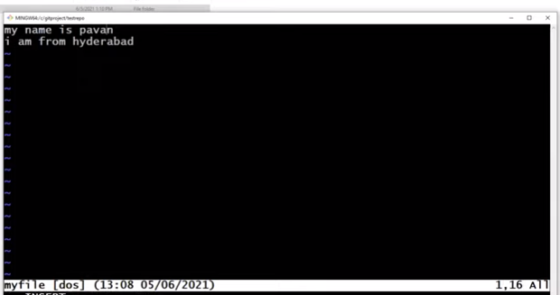

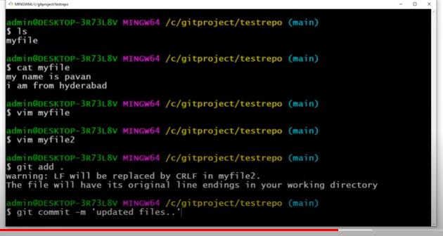

Here directly creating myfile2 and moving to staging both files

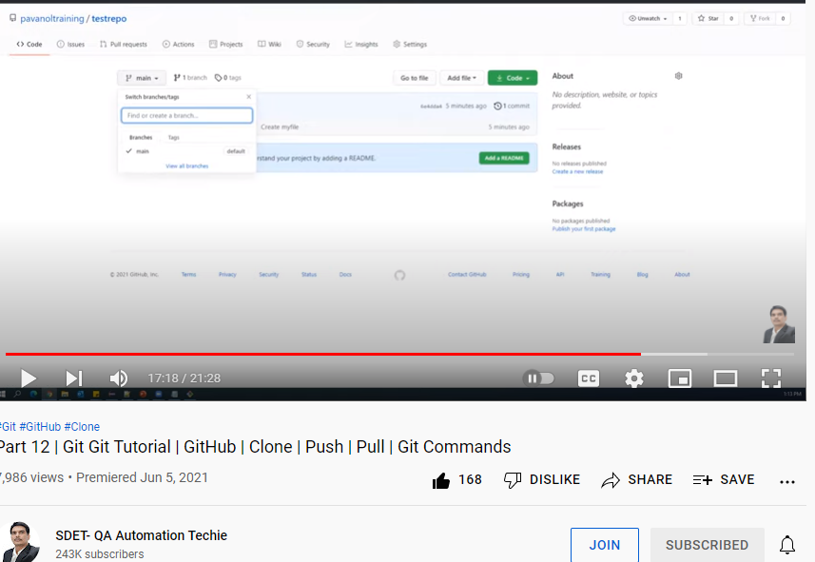

Next going to push myfile1 and myfile2 into remote repository

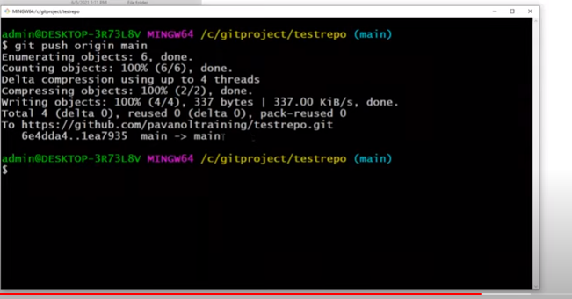

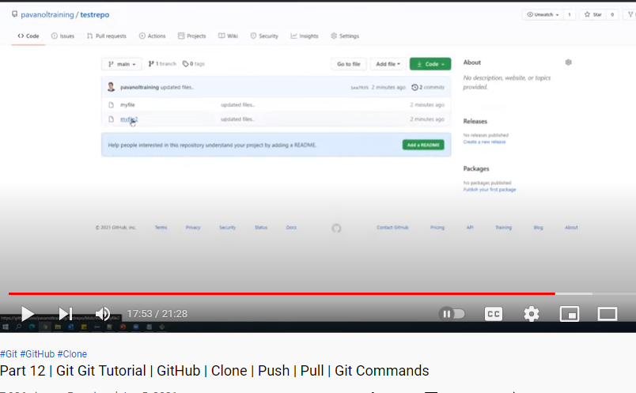

Below screenshot is going to pull the modified detail in the remote repository from myfle2 then pulling command to see the updated info in the local file

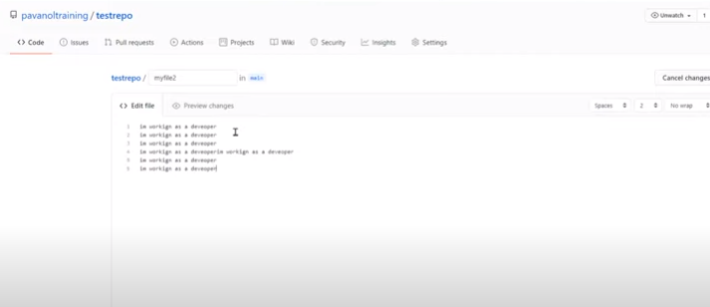

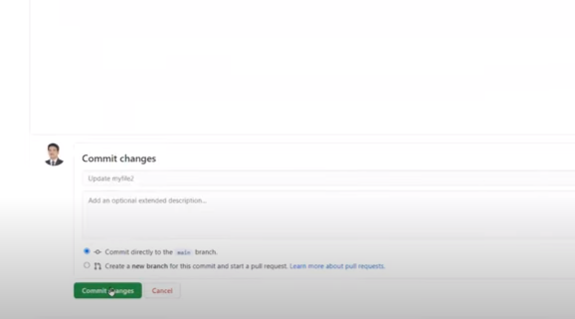

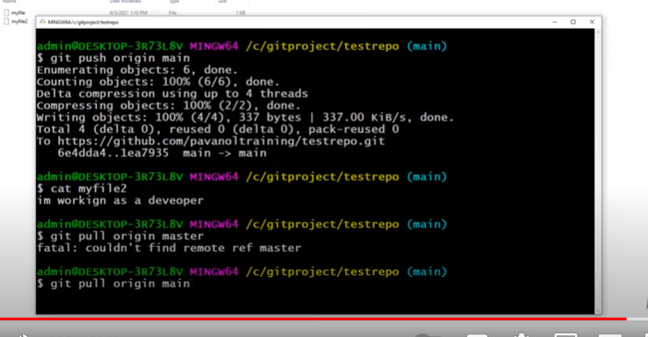

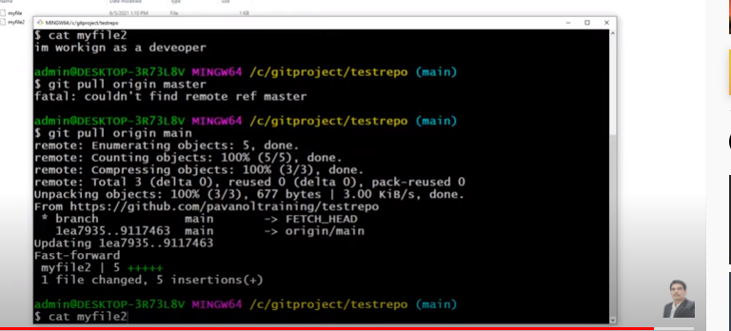

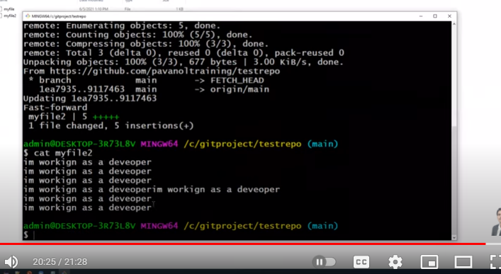

MOSH video - https://www.youtube.com/watch?v=8JJ101D3knE&t=2005s

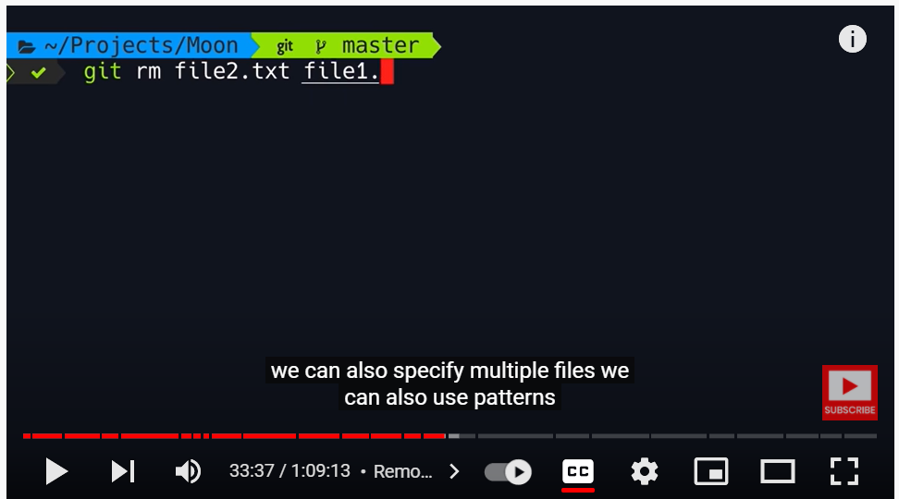

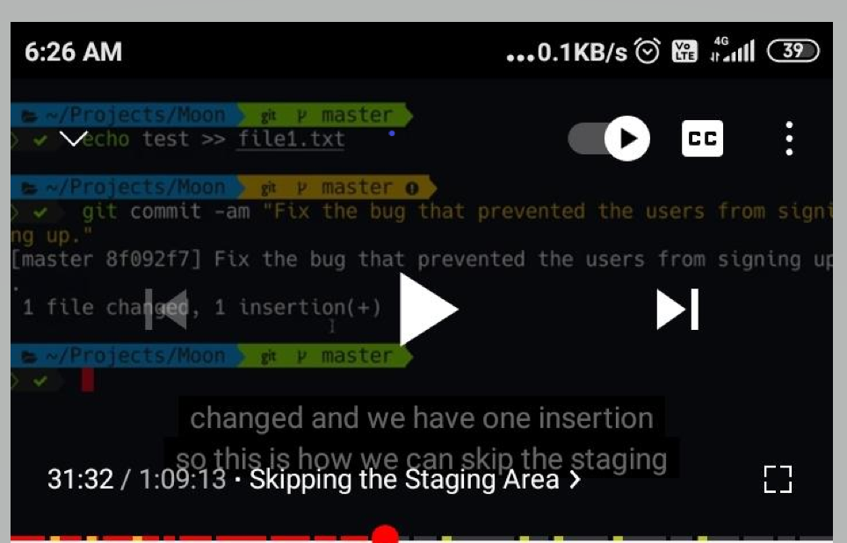

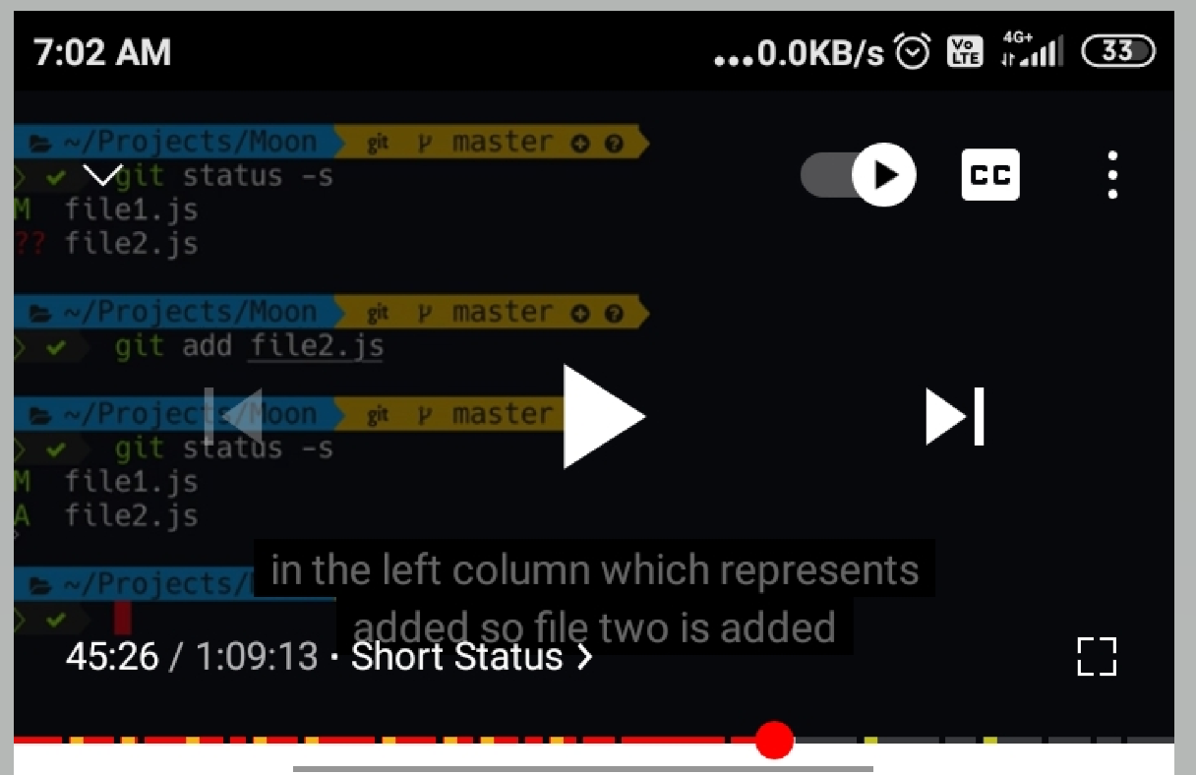



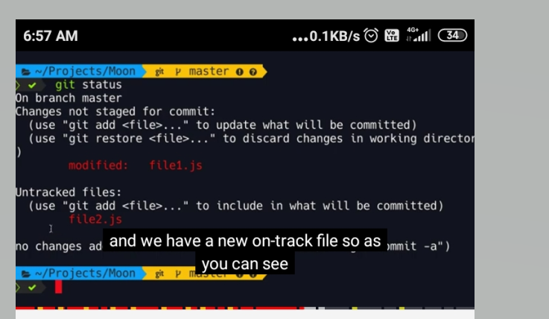

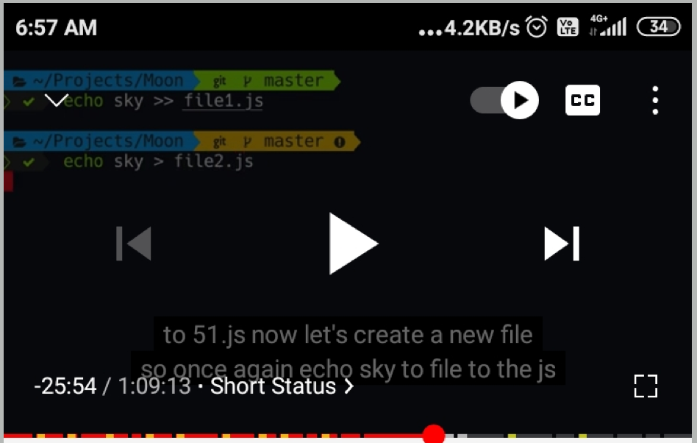

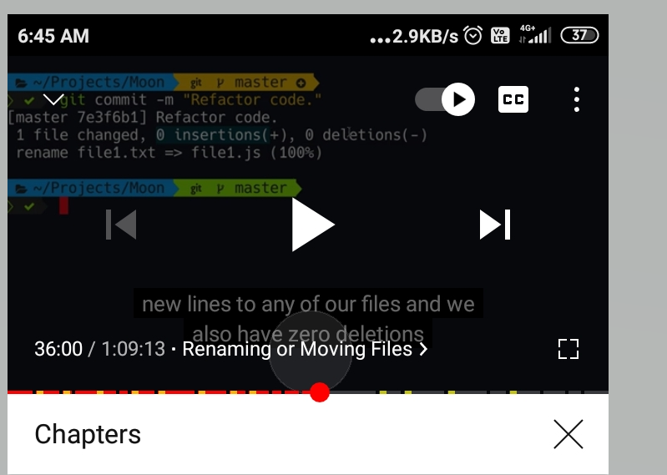

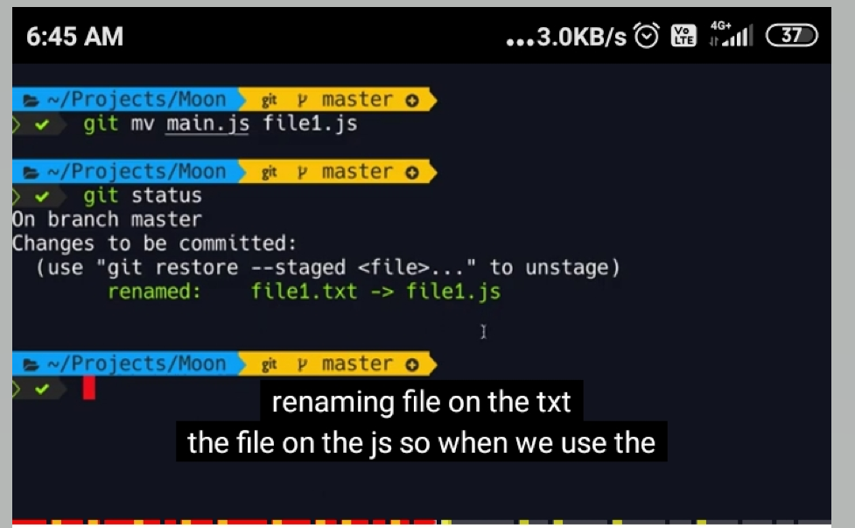

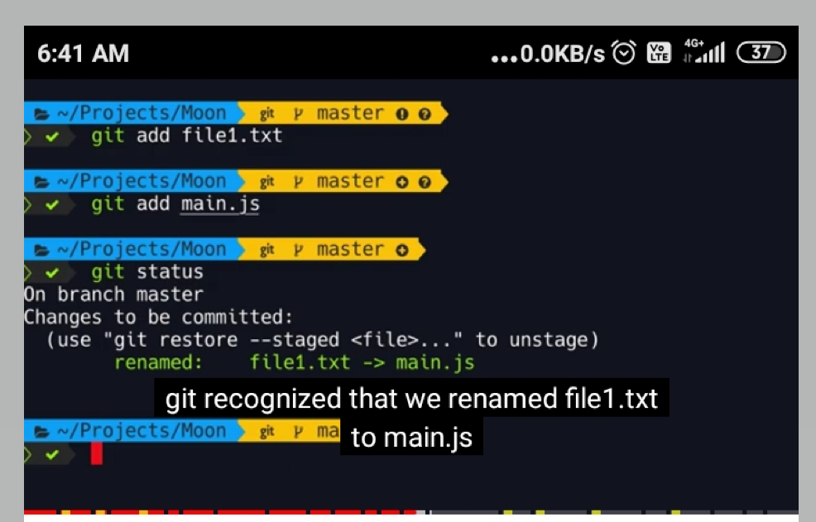

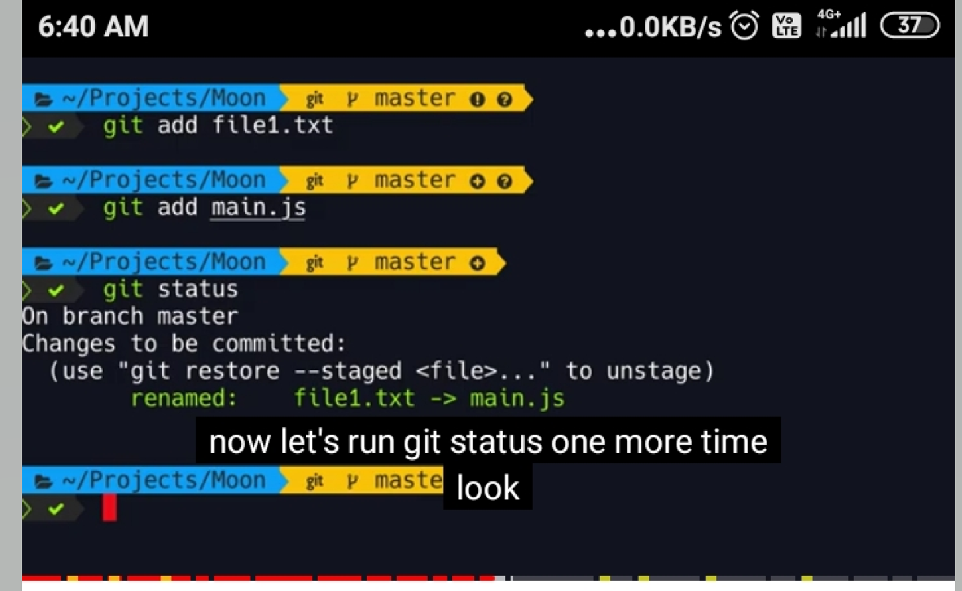

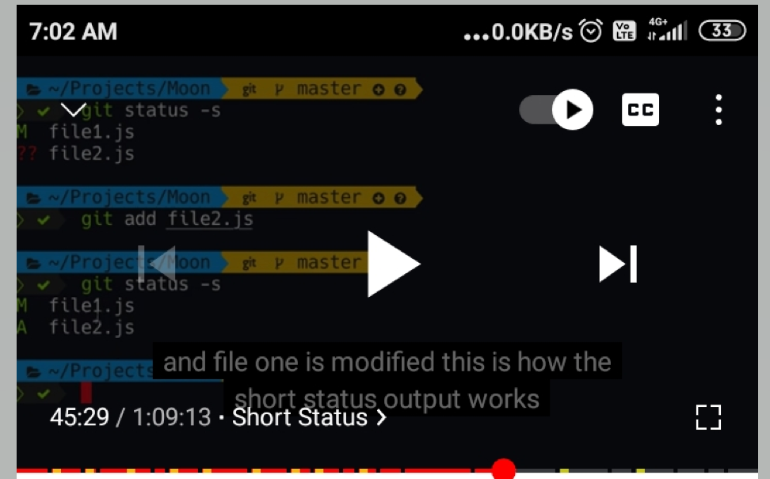

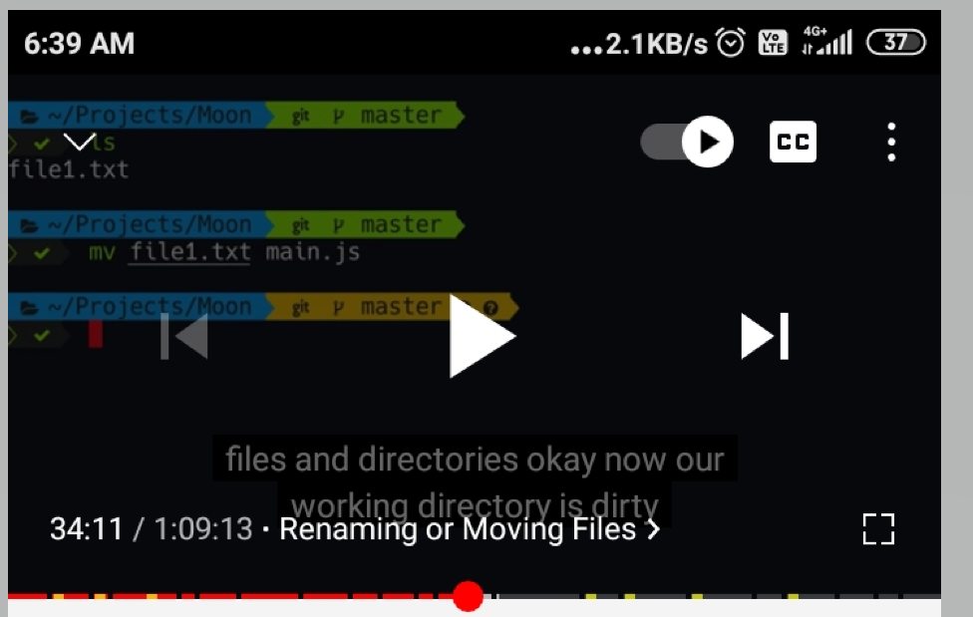

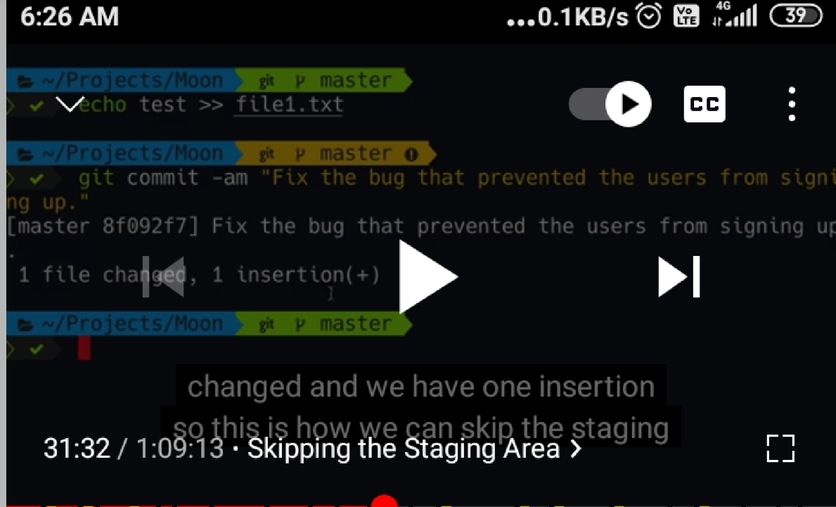

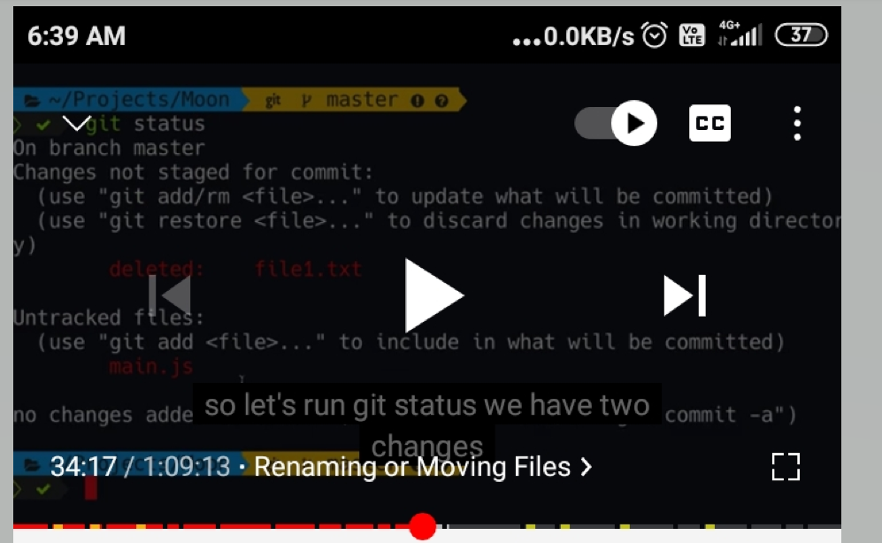

Git diff - will show what is in the working directory and what is in staging directory

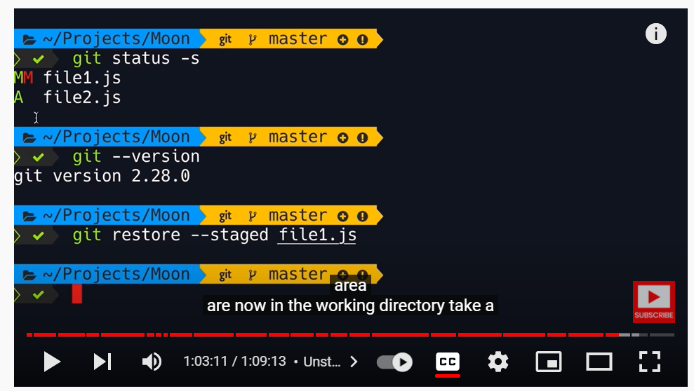

Git restore –staged file1.js will move the file from staging directory to working directory

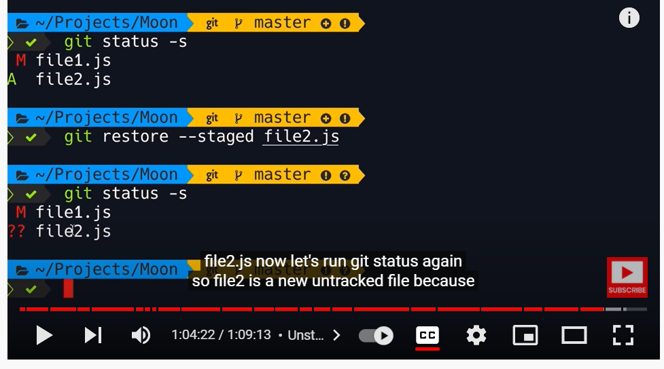

2 ?? symbol mentions its in untracked files

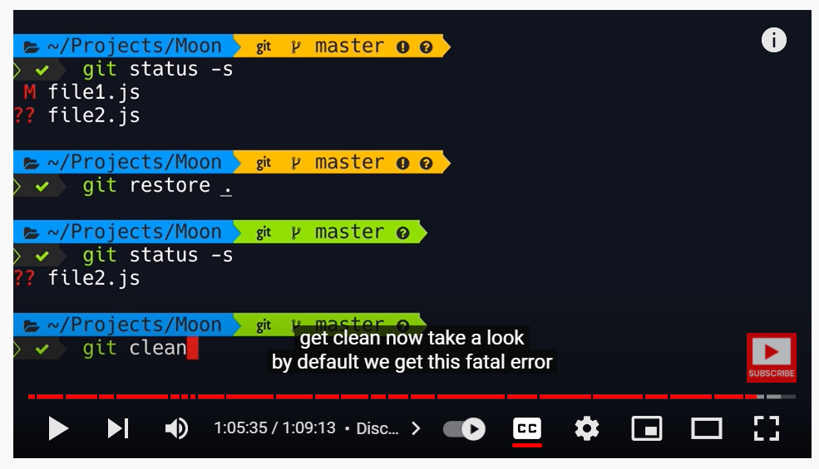

Git restore . will undo all the local changes

?? if we have question mark like that that is untracked files so git doesn’t know where to get those files to remove it through RESTORE command. It doesn’t exist in our staging environment or in our repository.

Git clean will do complete clean(we can’t retrieve from anywhere)

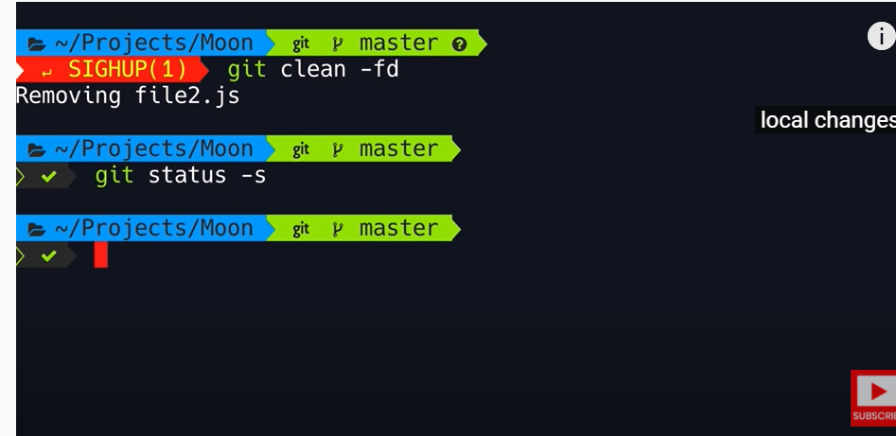

Lady trainer Edureka - <https://www.youtube.com/watch?v=xuB1Id2Wxak>

Need to create one repository in GIT HUB

Need to initiate one local repository in local folder and that need to be initiated by “git initreponame”

By this method through git hub or directly can create one folder in the local drive.

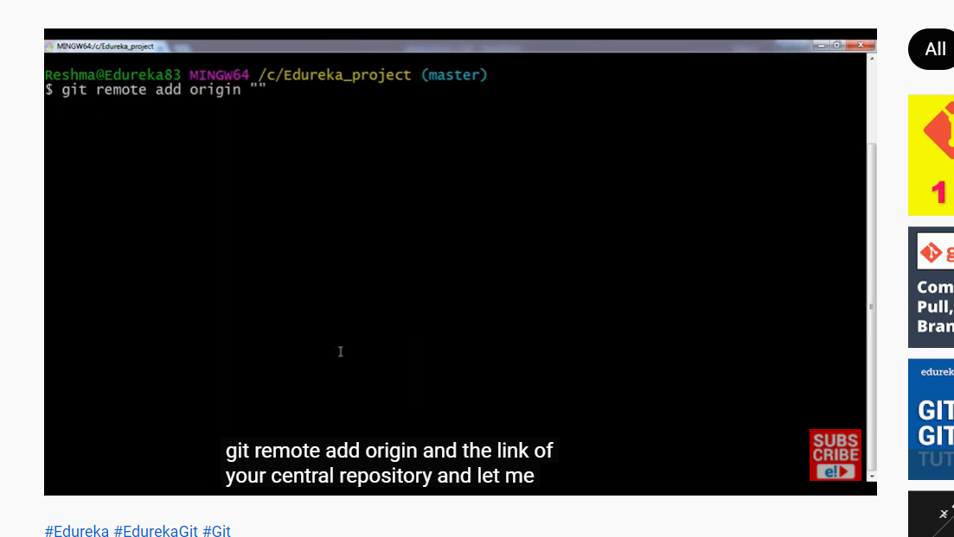

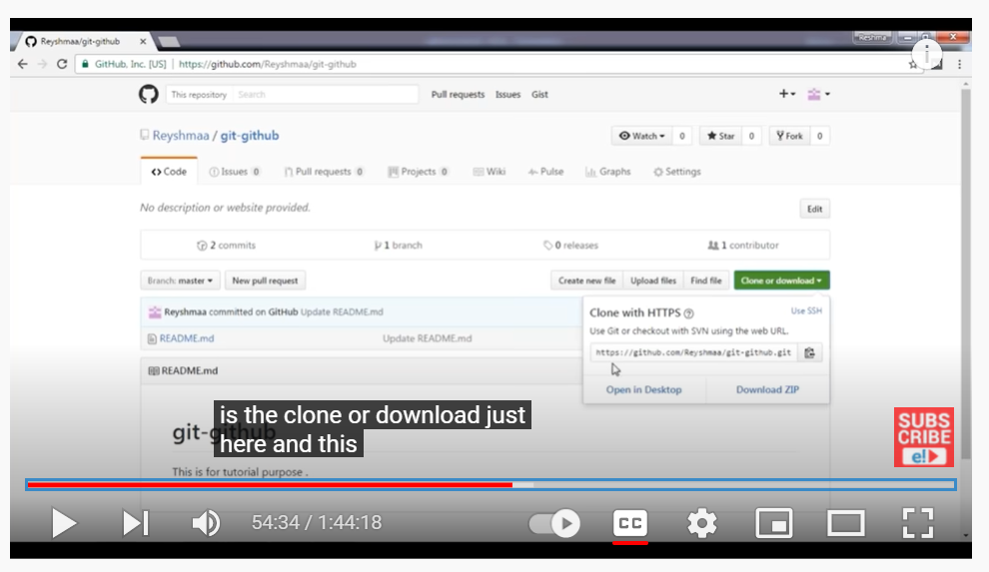

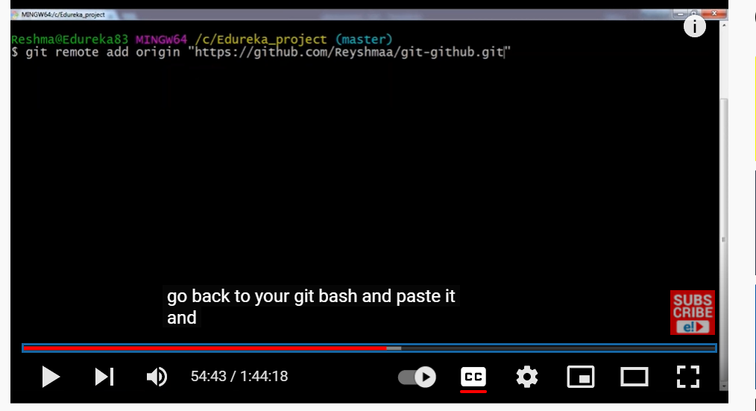

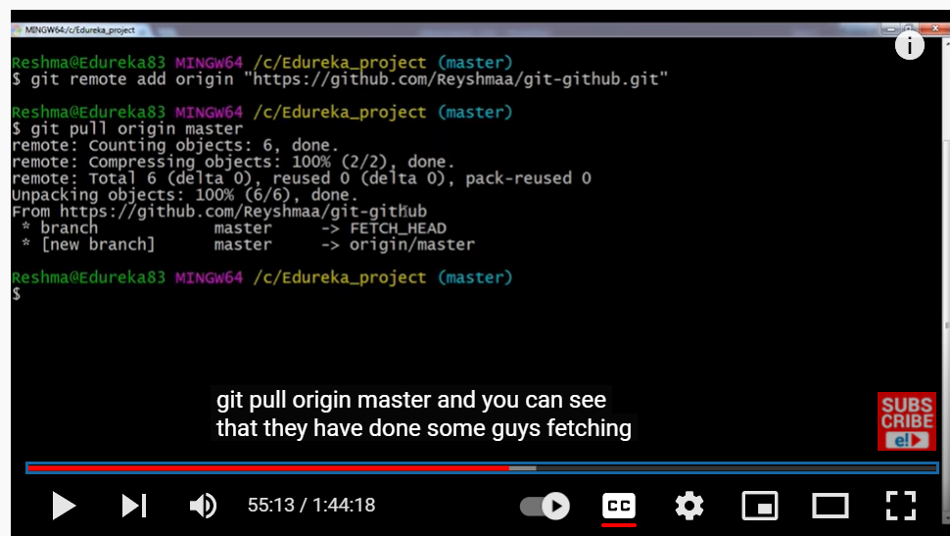

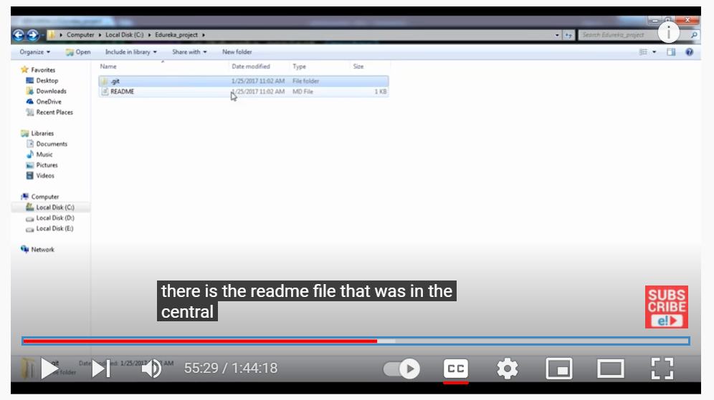

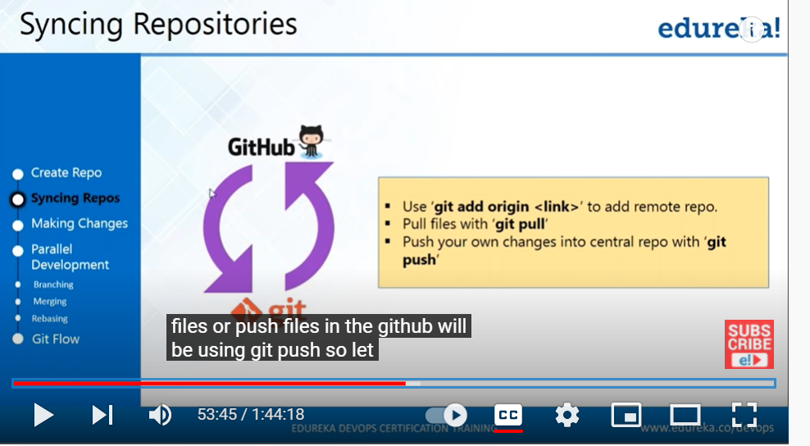

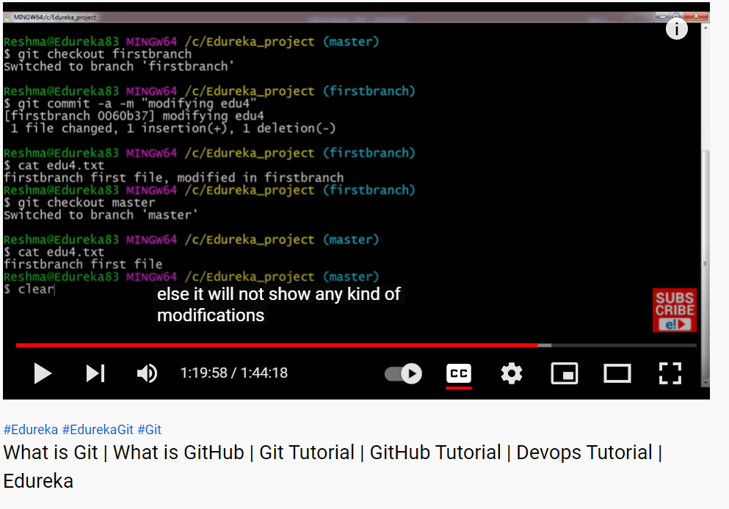

Git pull is directly pulling the file from central repository to placing into local directory or connecting in your master branch.

Git fetch is directly pulling the file from central repository and placing in different branch which is not connected with your work flow. If you doing git fetch then need to merge it so that u can see all the changes in local repo

Git pull is equal to git fetch plus git merge

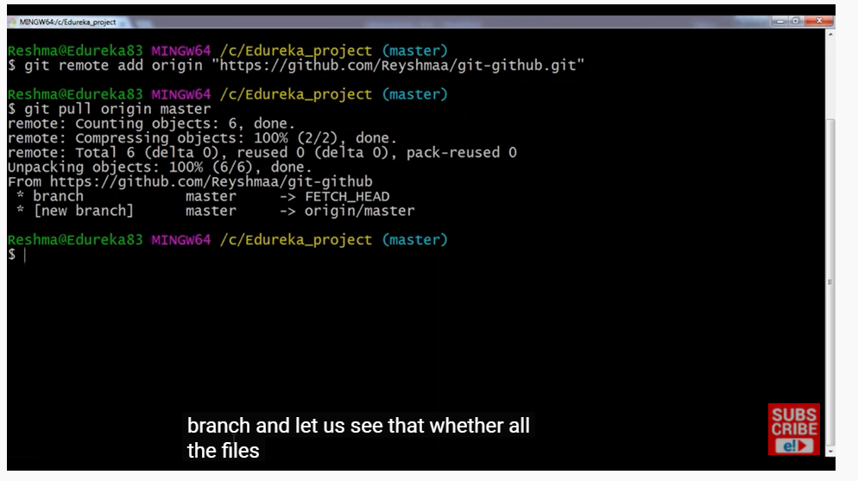

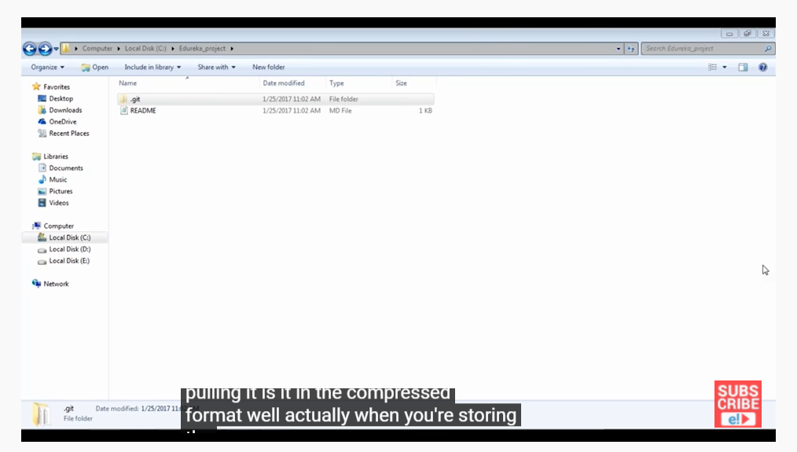

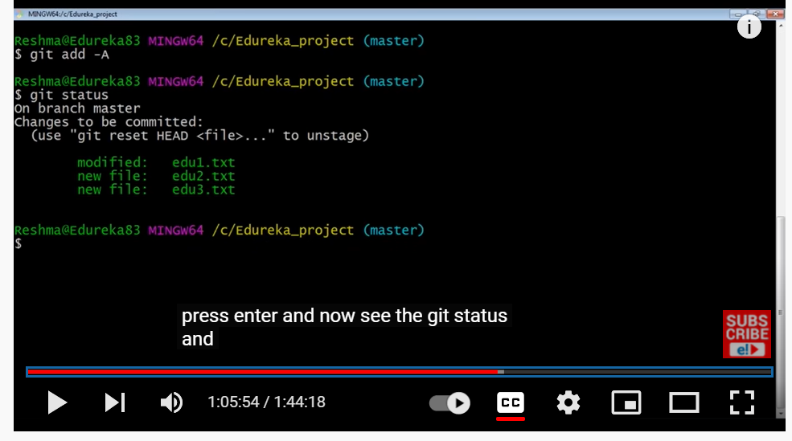

Git add -a (to add all to staging or index)

Edu1 created added committed then modified

Edu2 Edu3 created

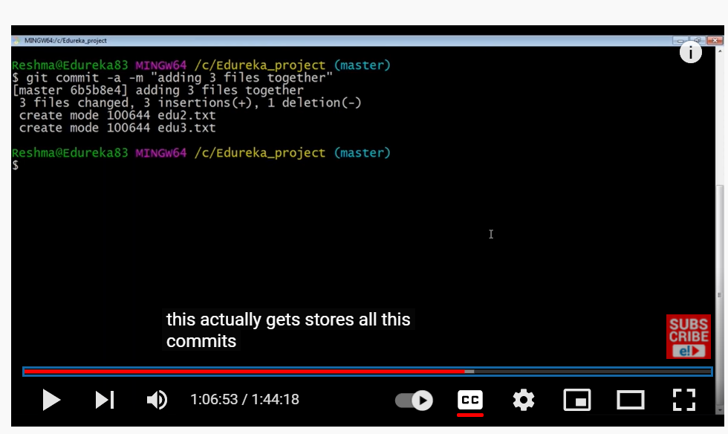

To commit all the files in single shot

Git log - will show what we have done so far

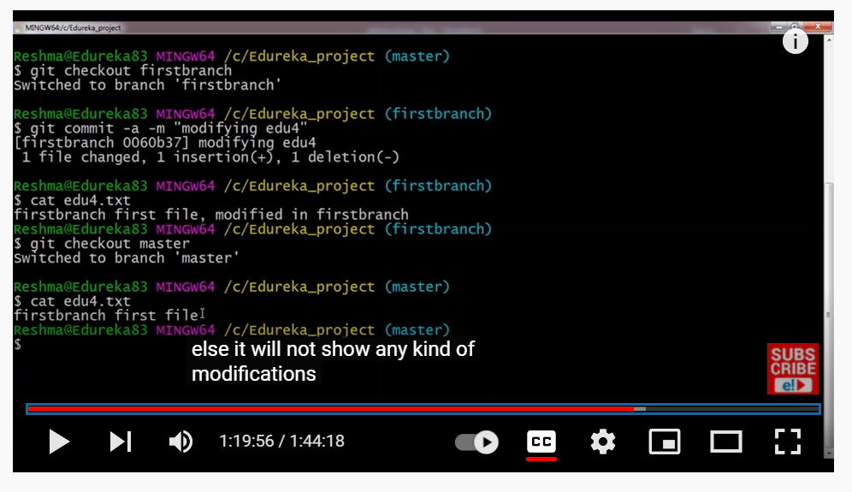

Cat will show what modification done on that edu4.txt

Even if we merge firstbranch into master still we will have edu4.txt

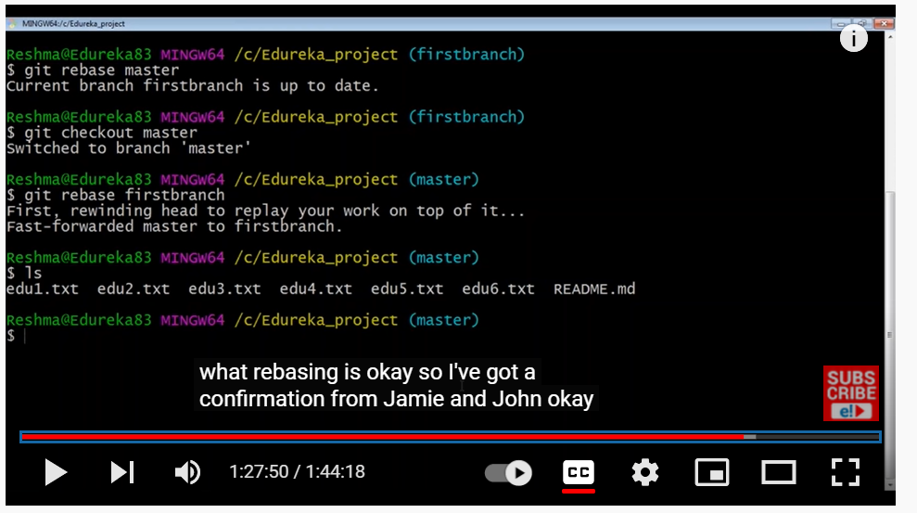

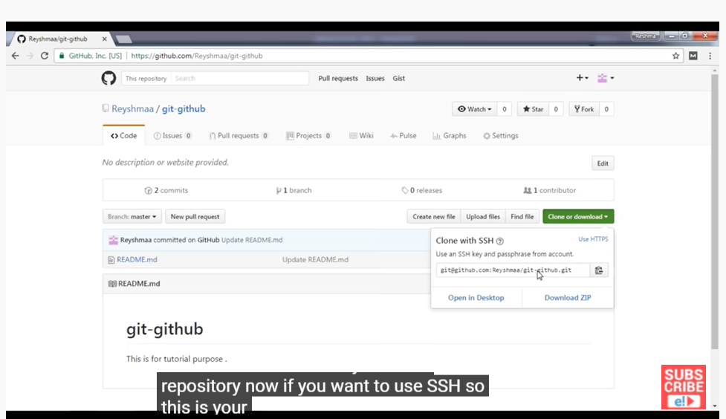

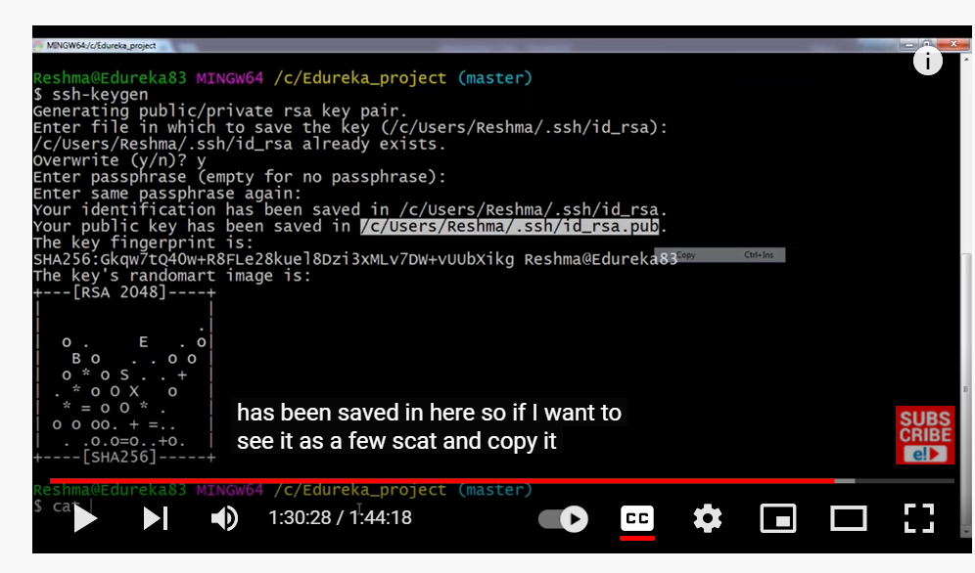

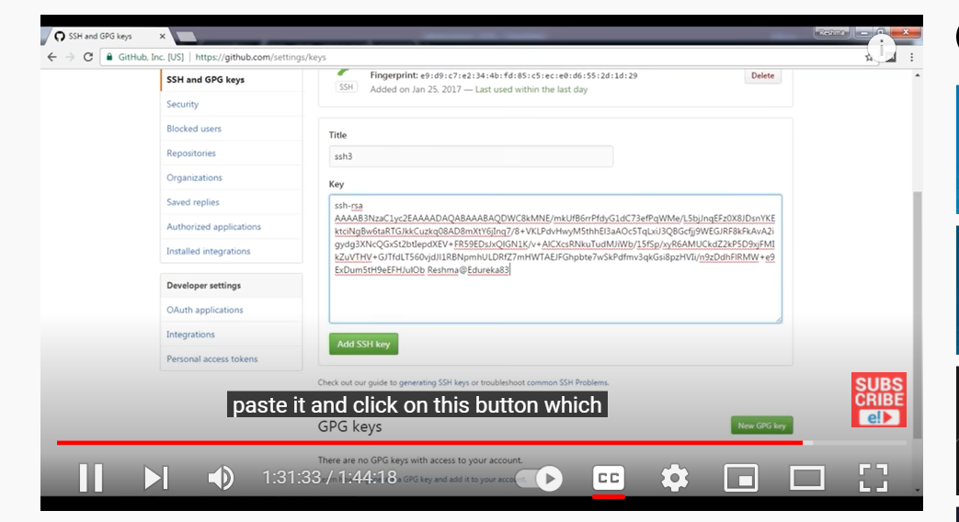

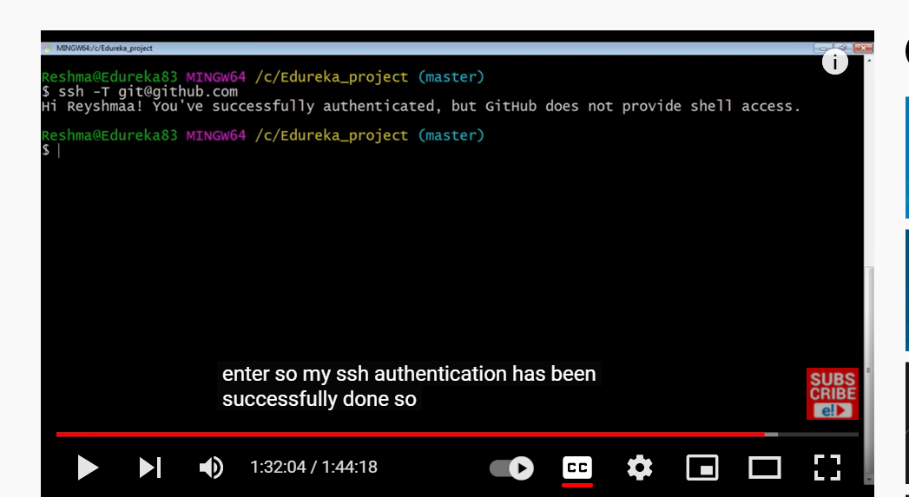

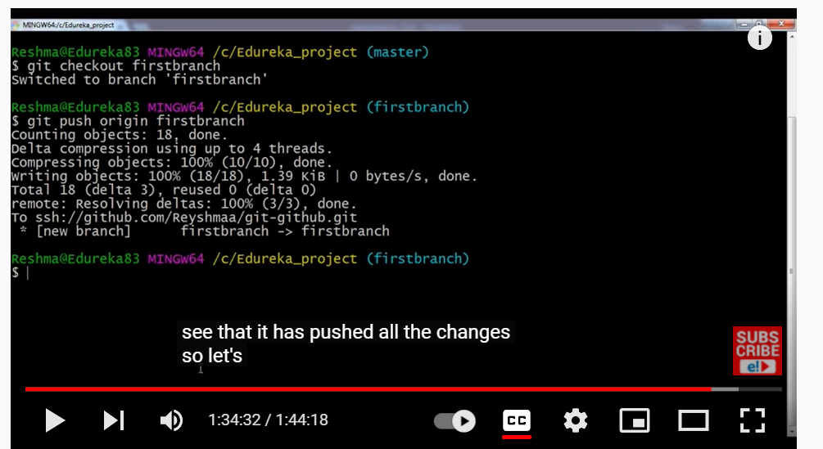

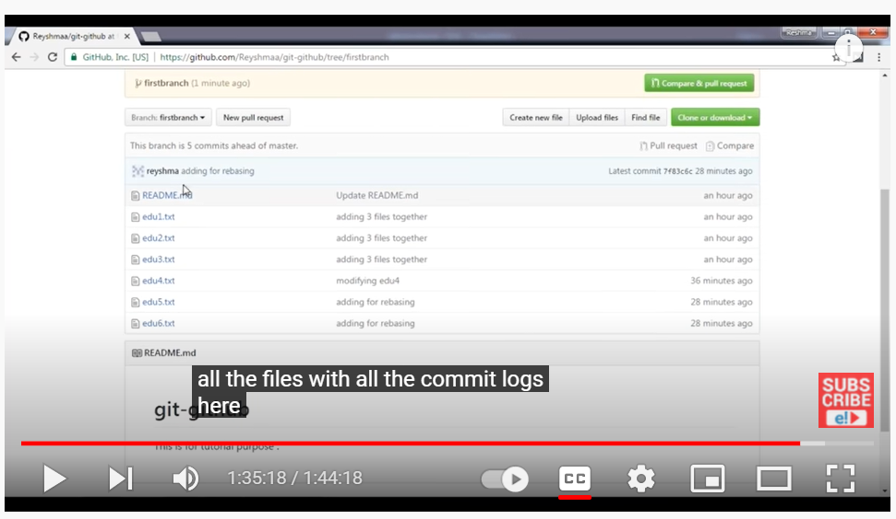

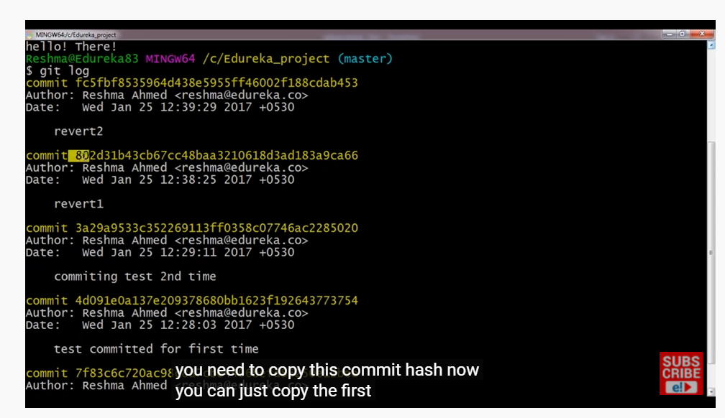

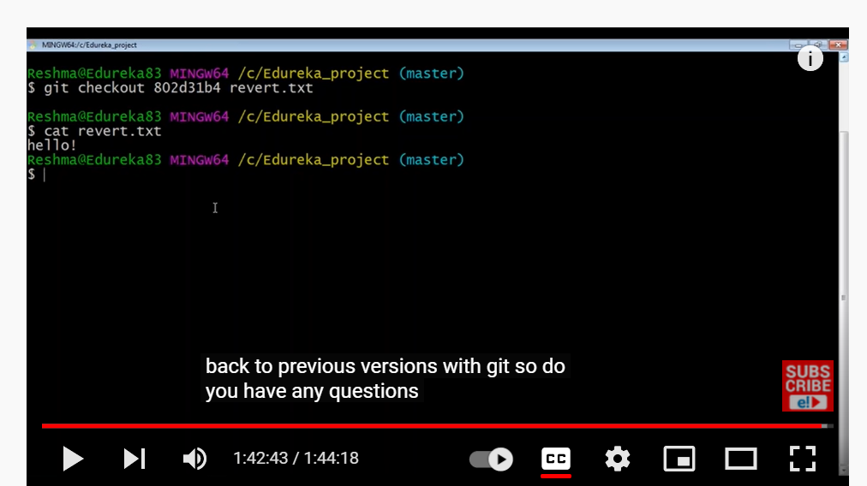

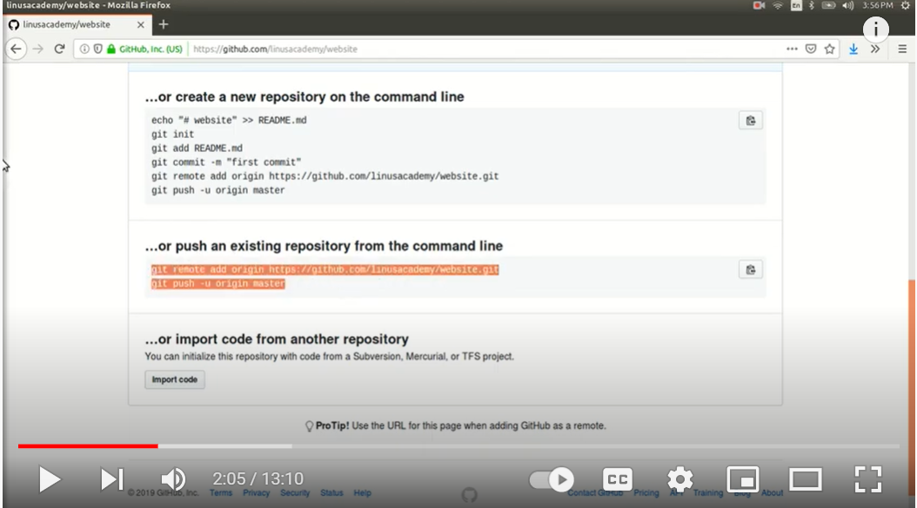

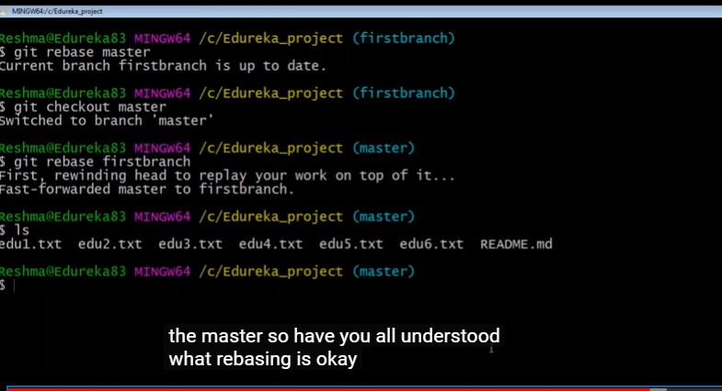

Git rebase master - that mean it is trying merge the files from master to firstbranch but already all those 4 files in firstbranch that’s the reason it is showing as “firstbranch is up to date”.

Git rebase firstbranch - that mean it is trying merge the files from firstbranch to master so those edu5 and edu6 also added into that master file which was not there earlier.

Git push pull stash rebase revert

<https://www.youtube.com/watch?v=b5oQZdzA37I&t=4s>

git push --set-upstream origin feature1 - This command used to create feature1 branch in remote repository for moving feature1 branch from local drive to remote feature1 branch. Always same branch name should be available in both local and remote.

we should not create it at 2 places, you should create at one place and sync at other place, meaning you can create on local and push to remote or create at remote and pull on local.

thisa@LAPTOP-VUFDHINT MINGW64 /c/gitproject/TEST1 (branch1)

**$ git push --set-upstream origin branch1**

Enumerating objects: 23, done.

Counting objects: 100% (23/23), done.

Delta compression using up to 4 threads

Compressing objects: 100% (11/11), done.

Writing objects: 100% (23/23), 1.54 KiB | 524.00 KiB/s, done.

Total 23 (delta 4), reused 0 (delta 0), pack-reused 0

remote: Resolving deltas: 100% (4/4), done.

remote:

remote: Create a pull request for 'branch1' on GitHub by visiting:

remote: https://github.com/thirusankar/GITDEMO/pull/new/branch1

remote:

To https://github.com/thirusankar/GITDEMO.git

* [new branch] branch1 -> branch1

Branch 'branch1' set up to track remote branch 'branch1' from 'origin'.

**$ git pull origin branch4**

thisa@LAPTOP-VUFDHINT MINGW64 /c/gitproject1/TEST1 (branch1)

**$ git pull origin branch1**

From https://github.com/thirusankar/GITDEMO

* branch branch1 -> FETCH_HEAD

**fatal: refusing to merge unrelated histories**

thisa@LAPTOP-VUFDHINT MINGW64 /c/gitproject1/TEST1 (branch1)

**$ git pull origin branch4**

From https://github.com/thirusankar/GITDEMO

* branch branch4 -> FETCH_HEAD

**fatal: refusing to merge unrelated histories**

thisa@LAPTOP-VUFDHINT MINGW64 /c/gitproject1/TEST1 (branch1)

**$ git pull origin branchname --allow-unrelated-histories**

**fatal: couldn't find remote ref branchname**

thisa@LAPTOP-VUFDHINT MINGW64 /c/gitproject1/TEST1 (branch1)

**$ git pull origin branch1 --allow-unrelated-histories**

From https://github.com/thirusankar/GITDEMO

* branch branch1 -> FETCH_HEAD

Merge made by the 'ort' strategy.

TEST1/example1.txt | 3 +++

TEST1/example2.txt | 3 +++

TEST1/example3.txt | 2 ++

TEST1/example4.txt | 3 +++

4 files changed, 11 insertions(+)

create mode 100644 TEST1/example1.txt

create mode 100644 TEST1/example2.txt

create mode 100644 TEST1/example3.txt

create mode 100644 TEST1/example4.txt

Moving source code file

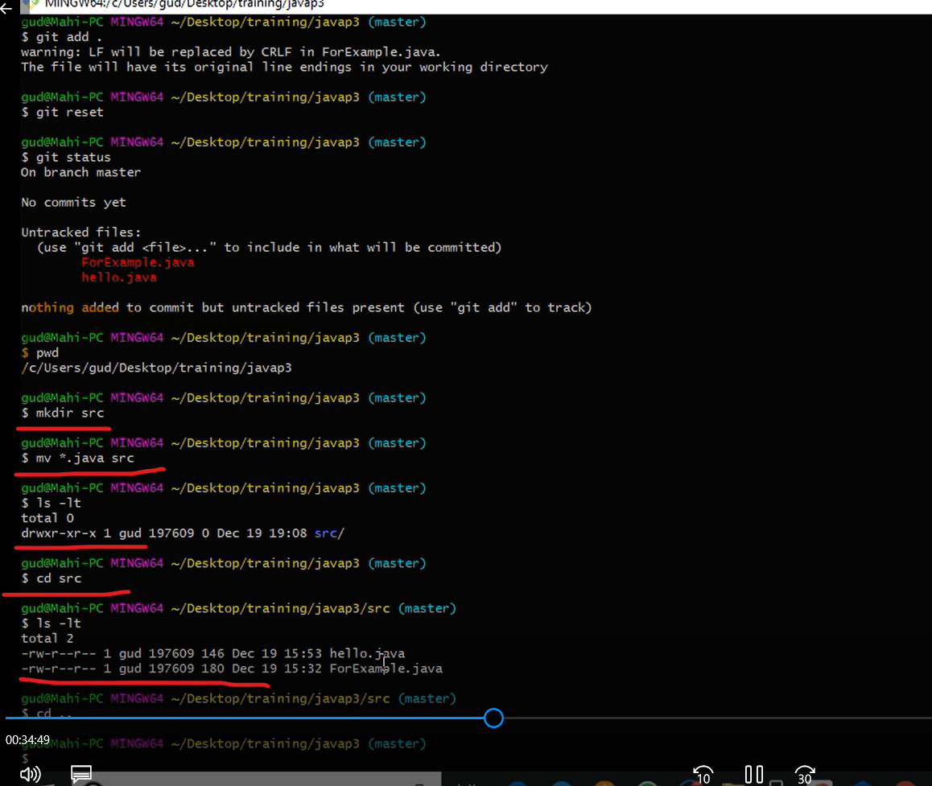

JAVA JAR JENKINS WAR

<https://www.youtube.com/watch?v=woMAXn4e8NA> - Jenkins installation and Jenkins home directory change procedure

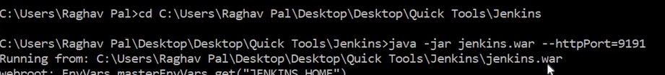

PARAMETERIZED JOB

[**https://www.youtube.com/watch?v=hgqBGNPlLlU**](https://www.youtube.com/watch?v=hgqBGNPlLlU)

**How to run the job local in Jenkins**

[**https://www.youtube.com/watch?v=JHt6QUsjxgE**](https://www.youtube.com/watch?v=JHt6QUsjxgE)